Pentameter

📏 What is Pentameter
# Source: Chatgpt (GPT-4-turbo) at [8/2/2025]
Pentameter is a poetic meter that consists of five metrical feet per line. It is the most common line length in English poetry, especially in formal verse, due to its natural alignment with the rhythms of English speech.

🧱 Structure
# Source: Chatgpt (GPT-4-turbo) at [8/2/2025]
- Each line has 5 feet
- Depending on the foot type, lines typically have 10 to 15 syllables
- Most common types:
  - Iambic Pentameter (da-DUM ×5)
  - Trochaic Pentameter (rare)
  - Anapestic Pentameter (uncommon)
  - Dactylic Pentameter (mostly in classical Greek/Latin)

📝 Example

Iambic Pentameter:
# Source: Chatgpt (GPT-4-turbo) at [8/2/2025]
Shall I compare thee to a summer's day?
— William Shakespeare

🧬 Variants
# Source: Chatgpt (GPT-4-turbo) at [8/2/2025]
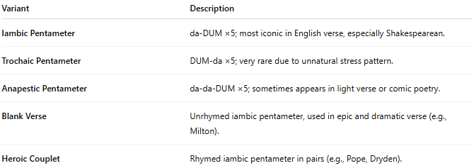
Variant | Description
Iambic Pentameter | da-DUM ×5; most iconic in English verse, especially Shakespearean.
Trochaic Pentameter | DUM-da ×5; very rare due to unnatural stress pattern.
Anapestic Pentameter | da-da-DUM ×5; sometimes appears in light verse or comic poetry.
Blank Verse | Unrhymed iambic pentameter, used in epic and dramatic verse (e.g., Milton).
Heroic Couplet | Rhymed iambic pentameter in pairs (e.g., Pope, Dryden).

🎭 Effect in Poetry
# Source: Chatgpt (GPT-4-turbo) at [8/2/2025]
- Matches the natural cadence of English
- Ideal for narrative, dialogue, or reflection
- Allows room for emotional depth and philosophical content

📚 Where It's Found
# Source: Chatgpt (GPT-4-turbo) at [8/2/2025]
Pentameter is foundational in:
- Shakespearean drama (blank verse)
- Sonnets (especially Elizabethan sonnets)
- Narrative epics (e.g., Paradise Lost by Milton)
- Augustan poetry (heroic couplets by Pope, Dryden)
- Romantic and Victorian poetry
- Modern formal poetry, including neo-formalist works

